



**REEVALUATE OUR STRATEGY TO OBTAIN OUR FULL CITIZENSHIP**

**SUMMARY OF THE SITUATION**

Procedures for the cooperative started in 2016. You can see a history of these procedures [here](https://coopassist.ca/historique/). We have built and proposed a complete, [turnkey solution](https://coopassist.ca/wp-content/uploads/2020/05/Coop-ASSIST-Programme-APA.pdf) for the government that is very [advantageous economically](https://coopassist.ca/wp-content/uploads/2020/05/ASSIST-Economique.pdf). Our approach until recently has mainly been to lobby behind closed doors with the government authorities. (Click on the links in the document for more information)

**THE LAST MEETING WITH THE GOVERNMENT**

In December 2019 we had a meeting with the cabinet of Mrs. McCann and all senior officials after the broadcast of [this report](https://ici.radio-canada.ca/nouvelle/1432573/programme-assistance-personnelle-handicapes-chsld-jonathan-marchand). Here is a summary report of the meeting provided by our [strategic advisers](https://www.quentus.ca/?lang=fr):

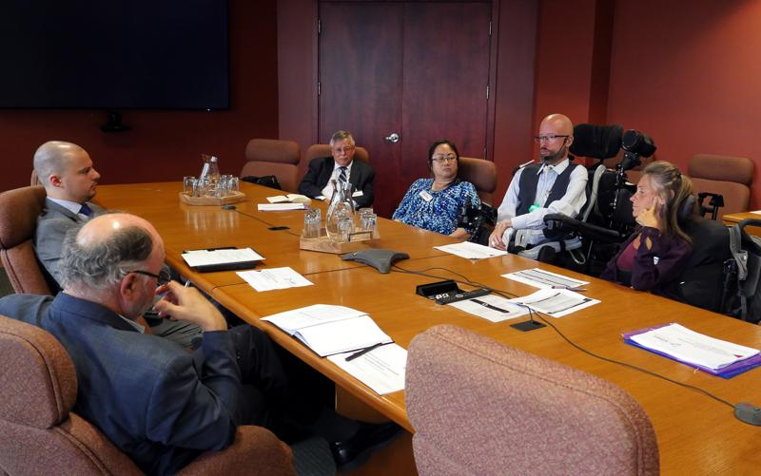

“Although the representatives of Coop ASSIST highlighted the benefits of the Coop ASSIST program, the meeting mainly focused on the issues raised by government representatives in the implementation of a new program, while the MSSS currently aims to improve existing programs, such as the Chèque Emploi-Service, as they believe that this will satisfy the services sought by Coop ASSIST. In addition, the government has indicated that those who have significant needs (24 hours a day) will have to go to seniors' homes / alternative residents. So, for the government, although it is ready to review certain things, those who are "rated" as long term care residents will have to keep going there. A full account of the meeting can be found [here](https://coopassist.ca/wp-content/uploads/2020/06/Sommaire-rencontre_16-décembre-2019_10-juin-2020.docx).

At the end of the meeting, the deputy minister ended up saying that they were going to do more work and would look into what was happening elsewhere in Canada.

Last February, we deposited a [document explaining what is being done elsewhere in Canada](https://coopassist.ca/wp-content/uploads/2020/05/Coop-ASSIST-Assistance-Personnelle-Canada-Quebec.pdf). The government's response 1 month later was "we will contact you in due course for a follow-up".

**THE COVID-19 CRISIS**

Thousands of people died in long term residences and the construction of seniors' homes and alternative houses was accelerated. Home support for major problems, the EESADs have lost a large part of their staff, the CLSC services are limited and the Chèque Emploi-Service self-managers still have difficulty recruiting and retaining their staff. The government has announced plans to invest in home support to keep people "as long as possible" at home.

**SINGLE ACCESS POINT**

Work has been ordered to review all the programs and measures intended for disabled and elderly people by the OPHQ in 2021. This is long-term work which can take several years. It is the idea of ​​the one-stop shop that we advanced during our meeting with Mrs. Marilyne Picard last year that is now being explored.

**REEVALUATE OUR STRATEGY**

Since our approach has not been fruitful so far, it is normal to ask questions about our strategy. In the Independent Living Movement there are several examples that exist where groups have made significant gains with limited means.

One of the most well documented examples is the [ADAPT](https://adapt.org/) group in the United States. (which means "Americans with disabilities for personal assistance programs today") The group has a [very rich history](https://adaptmuseum.net/gallery/index.php?/best_rated) of nonviolent direct action activism, and legal action in court. It works since the 70s and the United States has made a lot of progress. If we compare, Coop ASSIST already uses many, but not all, of these strategies. ADAPT advocates [a multi-pronged strategy](http://freeourpeople.net/disabilityorganizing101andbeyond/?page_id=54) to achieve this:

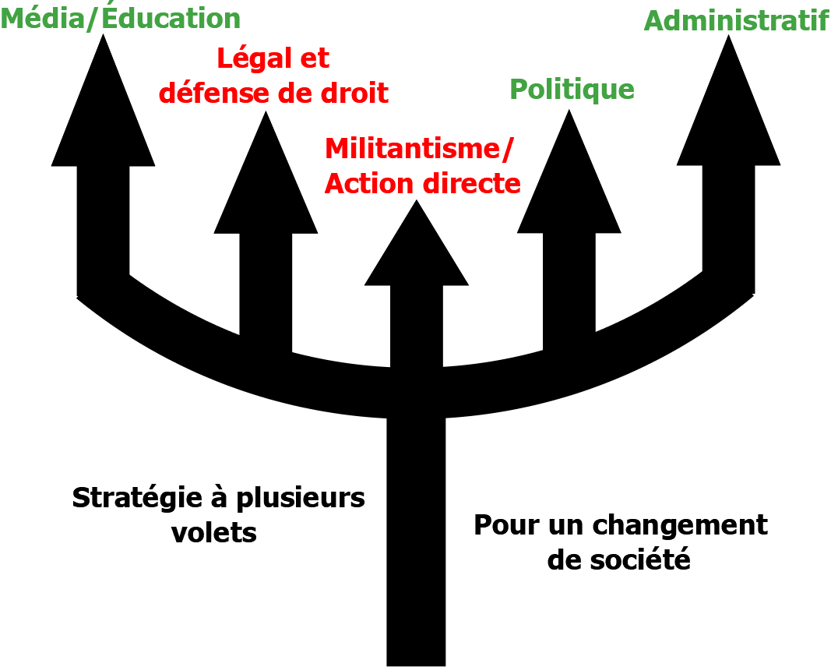

*(Image of a 5-tooth fork. Each tip represents a strategy, we can read: media / education, legal and defense of law, Activism / direct action, political, administrative and "Strategies with several components for a change of society" )*

|  |
| --- |
| **What Coop ASSIST already uses** |
| **Media / Education -** It's about using the media to get our message out and educating the population and the speakers of the issues facing them.  **Political -** This is the approach to elected officials, the opposition and the political apparatus as a whole. We use a lobbyist firm to support us.  **Administrative -** This is to make representation to bureaucratic bodies. For example, the OPHQ, civil servants, municipalities and professional orders. |
| **What could be added** |
| **Legal and defense of law** - It is to use legal remedies to advance our cause. For example, the provincial and federal courts, the Human Rights and Youth Commission and the United Nations Committee on the Rights of Persons with Disabilities.  **Activism, non-violent direct action and decentralization** - *Activism* is a form of collective commitment to a cause often aimed at protesting what is perceived to be an injustice.  *Nonviolent direct action* is an individual or group that acts by itself in a peaceful manner, in order to change a situation, without delegating power to an intermediary. For example, it can be symbolic actions, demonstrations, sit-ins, street blockades, hacktivism and civil disobedience.  Many believe that all forms of direct action are illegal, in reality, most are legal. Sometimes breaking a law to demonstrate an immoral situation (civil disobedience) is an effective measure. According to ADAPT, direct action can be the most fun and often gives the quickest results. However, there are many other types of direct action from which one can choose if the group is not ready for civil disobedience.  And to be effective, **decentralization** is a way of organizing so that working groups and managers are as independent as possible in carrying out their tasks. Decisions should be made based on our values ​​and the opinions of others. |

**EXAMPLES OF WHAT HAPPENED ELSEWHERE**

It is always interesting to see how groups elsewhere like ours have managed to make progress. Here are some examples:

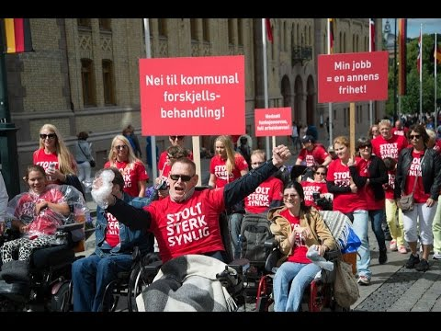

**- In Norway,** in the 90s, the [Uloba](https://uloba.no) coop blocked a bridge to be heard. It helped them in their negotiations with the government and the municipalities. They made themselves respected.

- **In Portugal**, a man who was taken in a long term care resident put himself [in a cage near the parliament](https://rr.sapo.pt/especial/132803/visita-de-marcelo-poe-fim-a-protesto-de-ativista-tetraplegico-em-gaiola). He managed to get personal assistance to live at home and opened the door to others.

**- In France,** a small group of 5 people with severe disabilities had blocked a street in front of the Ministry of Health. This action led to a reform and an emergency measure so that people with disabilities receive the money directly to manage their personal assistance services themselves.



- **In the United Kingdom**, in the 90s, hundreds of disabled people [chained themselves to public transport](https://www.bbc.com/news/disability-34732084) and blocked streets to assert their rights. These efforts have led to the creation of an important law against discrimination of people with disabilities.



* **In the United States,** the [Olmstead](https://www.olmsteadrights.org/) judgment opened the door for many to be able to leave the long term care residents as necessary. It is an important decision that recognizes the discriminatory nature of forcing someone to live in an institution instead of the community. ADAPT had supported the legal process throughout the legal process.

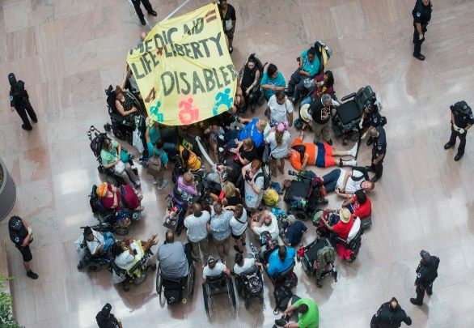Examples of **completely legal** actions that could be carried out in small numbers here: pressure tactics on Facebook and Twitter, symbolic action in front of parliament, action in the national assembly, action in front of the Ministry of Health and the prime minister's office.

***Actions are decided by those who participate in them and considering what they are comfortable doing.***

**MAKING A DECISION**

We have to make a decision in our best interests.

To start the discussion, here are some examples of resolutions that can be adopted. According to our discussion we can change them.

**Resolution example # 1 to CONTINUE with our current approach by using the media, the political and administrative process.**

**Resolution example # 2 to ADD activism, nonviolent direct action and decentralization to our approach.**

|  |  |
| --- | --- |
| **Resolution example #1** | **Resolution example #2** |
| Considering that our file is still being studied at the Ministry of Health and Social Services (MSSS) and that Deputy Minister M. Gendron has agreed to study what is being done elsewhere in Canada.  Considering that there is still an opening on the part of the government.  Considering that our advisers are ready to get more involved and believe that the political and administrative process has not yet been completed.  Coop ASSIST is committed to **continuing with its strategic advisers, the steps already started with the government, with the oppositions, and the media** so that people with disabilities needing personal assistance obtain their full citizenship. | Considering that our efforts with the political apparatus in the background have not been fruitful up to date.  Considering that our requests deserve urgent attention and that we have been more than reasonable.  Considering that the government persists in pushing people with disabilities with greater needs towards CHSLDs or homes for the elderly and "Alternative pavilions".  Coop ASSIST is committed to **adding legal and defense of rights, activism, non-violent direct action and decentralization** to its strategy so that people with disabilities who need personal assistance obtain full citizenship. |

**THE CONSEQUENCES**

Before making a decision, it is important to consider the potential risks. Here are the possible consequences of the two example resolutions.

|  |  |
| --- | --- |
| **Consequences** | |
| **Resolution example #1** | **Resolution example #2** |
| **Continue with political / media / administrative** | **Add activism / direct action / legal remedies / decentralization** |
| * The government has made no commitment to set up the program and / or a pilot project. In addition, for those with significant needs it is the homes of the elderly or the CHSLD, long term residences. Thus, without additional pressure, we risk not getting what we ask for. | * Our strategic advisers work with the government on several files. If relations are strained with the government following our actions, there is a possibility that they will withdraw from our cause. |

**CONCLUSION**

During the meeting, the board of directors will take your questions and comments.

Together we will then adopt a resolution which will guide our strategy for the future. The main question we have to ask ourselves:

**Do we continue with our current strategy or add elements?**

Thank you and we look forward to seeing you soon!